**Brief Description**

This program takes a class list consisting of students’ IDs and names as an excel file ,different poll reports as csv files and answer keys of polls as excel files. The program can seperate different polls’ results from a single file and detects poll names by matching the question texts in report files and answer key files. If the same poll was given to the students multiple times, it is detected by the program and can be named and processed as independent polls with the same content. Attendance polls and quiz polls are separated.

The program outputs the attendance details into a spreadsheet file for each student; consisting of each student’s info, the number of attendance polls, student’s attendance rate and percentage.

Another output includes the results of polls that consists of students’ info and columns for each question (Q1, Q2…) stating if the student answered the question correctly by taking the value 0 or 1. This file also includes number of questions, success rate and success percentage for each poll.

Another output file that is produced by the program contains general statistics and reporting that are questions and choise wise histograms, pie charts and more. Histograms of each question showing the choise distribution by stating how many students have chosen each option and indicating the correct choice with a different color.

The final output is a global file that is preserved between different runs. It displays all the fields of the student list, several columns about polls such as their dates, numbers of questions and success percentages.

**Glossary**

Poll: An object that has questions and answer options allowing the participants to select one or multiple choices.

Attendance Poll: A poll that aims to collect the info of the participants that are present.

Quiz Poll: A poll doing the job of a quiz.

Student: An object with ID and name information that makes the choices in polls.

Question: An object that has a question text, a correct answer and the information of the poll it belongs to.

Answer: An object representing the choice a student makes for a question.

Correct Answer: The correct option for a question.

Attendance Rate: The amount of attendance polls a student has anwered over the number of total attendance polls.

Attendance Percentage: Attendance rate calculated over a hundred.

Number of Questions: The amount of questions in a single poll.

Success Rate (of Polls): The amount of students that answered the poll correctly over the total amount of anwers.

Success Percentage (of Polls): Success rate calculated over a hundred.

Histogram: A question or choice wise graph representing the data distribution for each poll.

Pie Chart: A statistics graph representing question or choice wise poll data in numerical proportions.

**Functional Requirements**

* The program must be able to seperate different polls from the same csv file.
* The program must be able to seperate attendance polls and quiz polls.
* The program must be able to identify a student even if they used different or incorrect forms of names and e-mails.
* The program must be able to recognise students by matching their information from both the class list file and the poll result files.
* The program must be able to detect if a student has answered a question correctly or not.
* The program must be able to determine the name of each poll by matching the questions texts in poll result files to the question texts in answer key files.
* The program must be able to detect if a poll with the same content has been assigned multiple times and consider them independent polls.
* The program must be able to calculate the attendance rate and percentage of each student.
* The program must be able to calculate success rate and percentage of each poll.

**Non-Functional Requirements**

* Input files will be given as csv and excel files.
* Outputs will be excel files.
* The program should be able to preserve a global output between different runs.

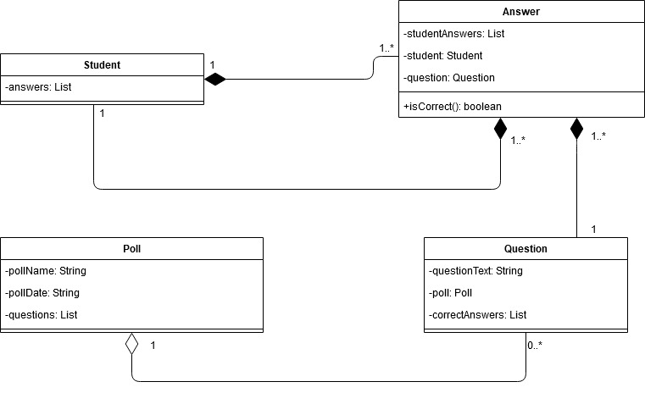**DOMAIN MODEL**

**SYSTEM SEQUENCE DIAGRAM**

